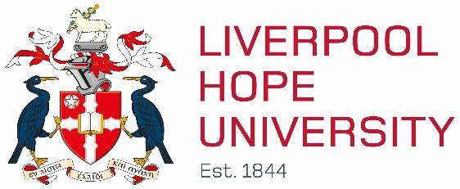

Erasmus Policy Statement

Internationalism is one of the key strategic aims of Liverpool Hope University. Its commitment to this is set out in the current Corporate Plan. “The University shall continue to extend its collaborations with institutions and academics across the world, and especially extend its global network of partnership with institutions that share its mission and values. This network will increasingly enhance Liverpool Hope University’s value and service. These global partnerships foster opportunities for research, exchange at faculty and student level, and greater internationalisation of the University’s curricula and ethos.

The University is concerned both with knowledge and competence in academic disciplines, and also with the formation and, indeed, the transformation of its students into graduates prepared for making a difference for good in the world.” There are three pillars to its international strategy, internationalisation, international student recruitment and partnerships. We define internationalisation as the process of internationalising the educational, cultural and social experience of all students and staff of the University. European cooperation and partnerships are integral to this, as are those beyond Europe.

As the only ecumenical Christian University foundation in Europe and distinctive because of this characteristic anywhere in the world, Liverpool Hope University proactively seeks partners who share our mission and values. In its mission the University strives to provide opportunities for the well-rounded personal development of Christians and students from other faiths and beliefs, educating the whole person in mind, body and spirit, irrespective of age, social or ethnic origins or physical capacity, including in particular those who might otherwise not have had an opportunity to enter higher education and to contribute to the educational, religious, cultural, social and economic life of Liverpool, Merseyside, the North-West and beyond. The development of an international strategy is about more than student recruitment. It has to tackle the challenges of a Global Society and draw upon the founding mission and vision, contextualising it for the 21st Century.

The University has a number of strategic partnerships with high quality overseas institutions, which share the University’s mission and values in a wide range of countries including in Europe France, Spain, Malta and Belgium. These partnerships aim to foster collaborative academic research, deliver innovative programmes or academic progression, or provide study abroad or exchange opportunities, and special friendship. It is the shared mission, rather than the geographical location, which is of primary importance to the University. With regard to partnerships our most important objectives are to:
Develop close working links with a range of overseas partners, especially those sharing Hope’s mission, ethos and academic interests.
Foster staff exchange programmes.
Develop academic programmes for joint delivery.
Increase student exchange programmes and study/work abroad opportunities.
Establish joint institutes for collaborative research.
Prepare joint applications for external funding from different sectors.

A key goal of the University’s Corporate Plan, 2016 to 2020, is to provide opportunities so that at least 50% of undergraduate students will have spent time abroad or volunteered or undertaken a work placement; the volunteering or work placement may be overseas. In particular we target students in their second year of a first cycle programme as we think this best fits the demands of degree study. Students and staff currently have mobility opportunities at the University’s partner institutions with whom it has an inter-institutional or cooperation agreement. These include consortium agreements for double and joint degrees with European partners.

